Name:CH.Shivamani H.No:2303A51806 Batch:26
SCHOOL OF COMPUTER SCIENCE AND ARTIFICIAL INTELLIGENCE |  |  |  |  | DEPARTMENT OF COMPUTER SCIENCE ENGINEERING
Program Name: B. Tech |  |  |  | Assignment Type: Lab |  |  | Academic Year:2025-2026
Course Coordinator Name |  |  |  | Dr. Rishabh Mittal
Instructor(s) Name |  |  |  | Mr. S Naresh Kumar  Ms. B. Swathi  Dr. Sasanko Shekhar Gantayat  Mr. Md Sallauddin  Dr. Mathivanan  Mr. Y Srikanth  Ms. N Shilpa  Dr. Rishabh Mittal (Coordinator)  Dr. R. Prashant Kumar  Mr. Ankushavali MD  Mr. B Viswanath  Ms. Sujitha Reddy  Ms. A. Anitha  Ms. M.Madhuri  Ms. Katherashala Swetha  Ms. Velpula sumalatha  Mr. Bingi Raju
CourseCode |  |  | 23CS002PC304 | Course Title |  | AI Assisted Coding
Year/Sem |  |  | III/II | Regulation |  | R23
Date and Day  of Assignment |  |  | Week7 – Wednusday | Time(s) |  | 23CSBTB01 To 23CSBTB52
Duration |  |  | 2 Hours | Applicable to  Batches |  | All batches
Assignment Number:13.3(Present assignment number)/24(Total number of assignments)
 | Q.No. | Question |  |  |  |  |  | Expected Time  to complete
 | 1 | Lab 13: Code Refactoring Using AI Assistance Improving Legacy Code for Readability, Maintainability, and Performance  Lab Objectives  The objectives of this laboratory exercise are to:  - Identify common code smells and inefficiencies in legacy Python programs.  - Use AI-assisted coding tools to refactor code for better readability and maintainability.  - Apply modern Python best practices while preserving original program behavior.  - Analyze performance improvements achieved through refactoring.  Learning Outcomes  After completing this lab, students will be able to:  - Detect and eliminate code duplication in Python programs.  - Refactor inefficient logic using optimized data structures and constructs.  - Improve code quality through meaningful naming conventions and documentation.  - Validate refactored code using test cases and performance comparison.  Task 1: Refactoring – Removing Code Duplication  Objective  To eliminate repeated logic by extracting reusable functions.  Task Description  Use AI assistance to refactor a legacy Python script that contains repeated blocks of code calculating the area and perimeter of rectangles.  Starter (Legacy) Code  # Legacy script with repeated logic  print("Area of Rectangle:", 5 * 10)  print("Perimeter of Rectangle:", 2 * (5 + 10))  print("Area of Rectangle:", 7 * 12)  print("Perimeter of Rectangle:", 2 * (7 + 12))  print("Area of Rectangle:", 10 * 15)  print("Perimeter of Rectangle:", 2 * (10 + 15))  Expected Outcome  - A reusable function to calculate area and perimeter  - No duplicated code blocks  - Proper docstrings for all functions  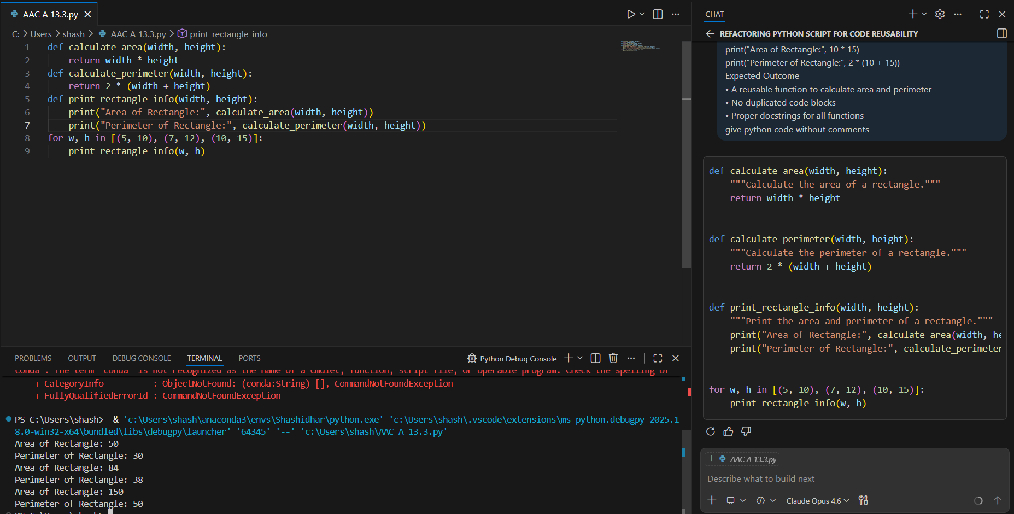  Task 2: Refactoring – Optimizing Loops and Conditionals  Objective  To improve performance by replacing inefficient nested loops with optimized structures.  Task Description  Use AI to analyze and refactor a script that checks the presence of elements using nested loops.  Starter (Legacy) Code  names = ["Alice", "Bob", "Charlie", "David"]  search_names = ["Charlie", "Eve", "Bob"]  for s in search_names:  found = False  for n in names:  if s == n:  found = True  if found:  print(f"{s} is in the list")  else:  print(f"{s} is not in the list")  Expected Outcome  - Optimized solution using set lookups or comprehensions  - Performance comparison before and after refactoring  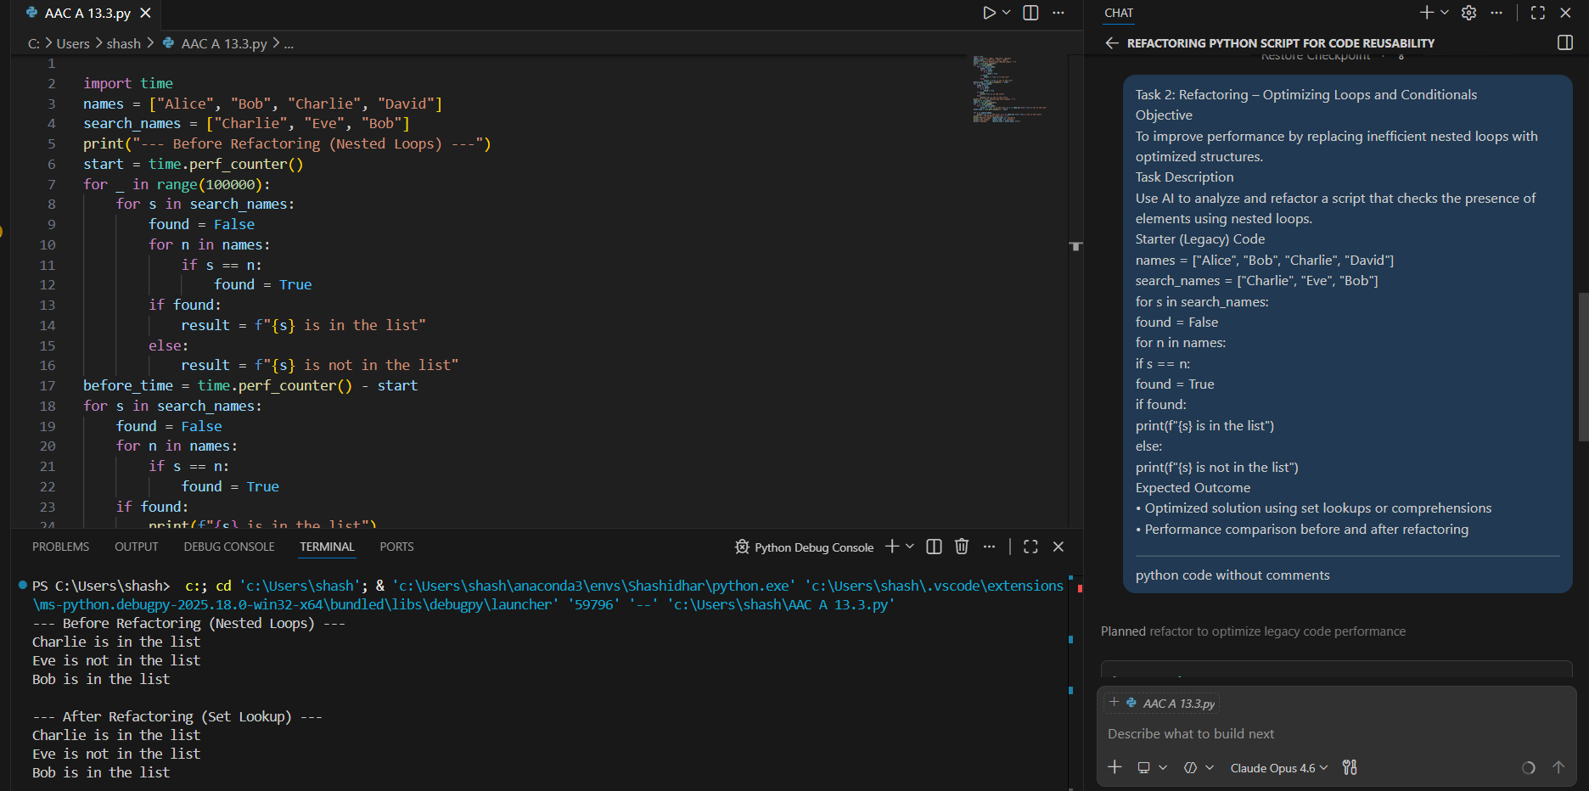  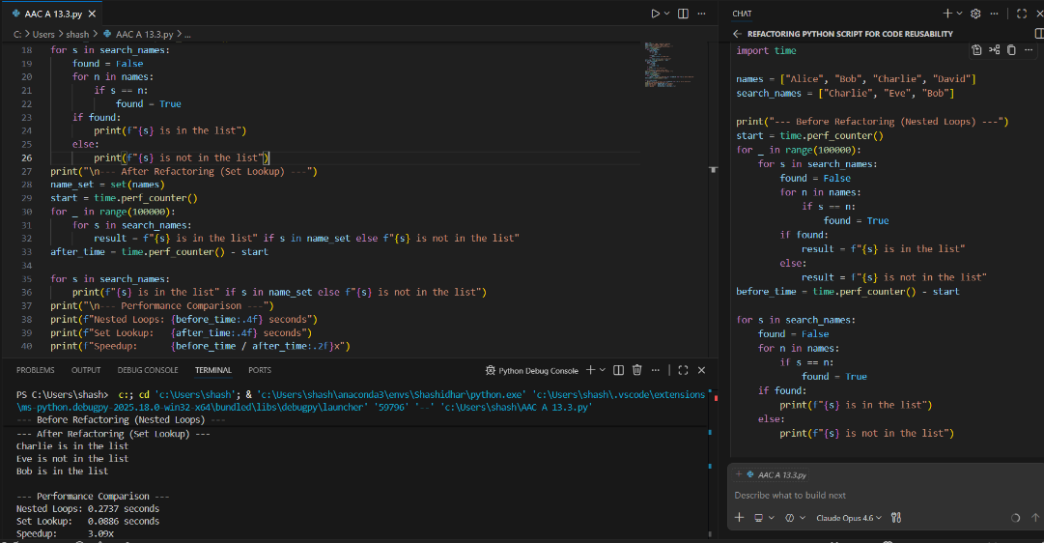  Task 3: Refactoring – Extracting Reusable Functions  Objective  To modularize code by extracting calculations into reusable functions.  Task Description  Refactor a legacy script where price and tax calculations are written inline.  Starter (Legacy) Code  price = 250  tax = price * 0.18  total = price + tax  print("Total Price:", total)  price = 500  tax = price * 0.18  total = price + tax  print("Total Price:", total)  Expected Outcome  - A function calculate_total(price)  - Cleaner and reusable code structure  - Proper documentation  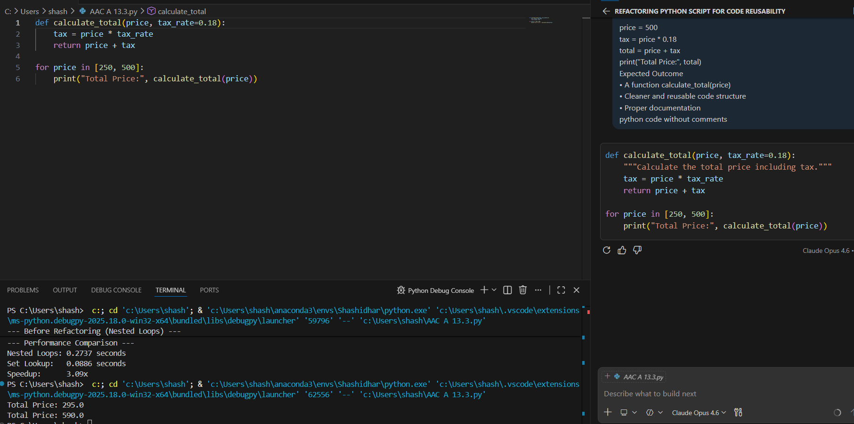  Task 4: Refactoring – Replacing Hardcoded Values with Constants  Objective  To improve maintainability by replacing magic numbers with named constants.  Task Description  Use AI to identify hardcoded values and replace them with constants.  Starter (Legacy) Code  print("Area of Circle:", 3.14159 * (7 ** 2))  print("Circumference of Circle:", 2 * 3.14159 * 7)  Expected Outcome  - Constants such as PI and RADIUS  - Cleaner, maintainable code  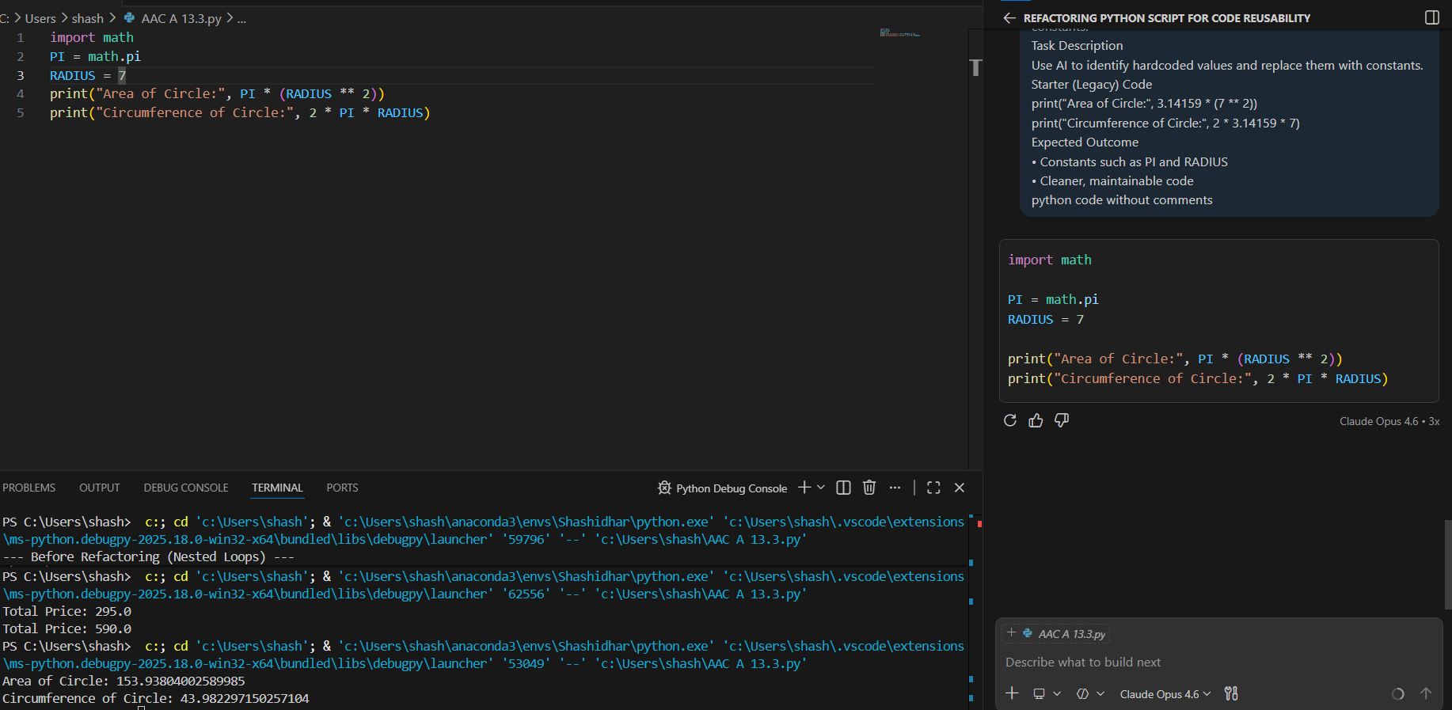  Task 5: Refactoring – Improving Variable Naming and Readability  Objective  To enhance readability using descriptive variable names and comments.  Task Description  Refactor a script with unclear variable names.  Starter (Legacy) Code  a = 10  b = 20  c = a * b / 2  print(c)  Expected Outcome  - Descriptive variable names  - Inline comments explaining logic  - Identical output  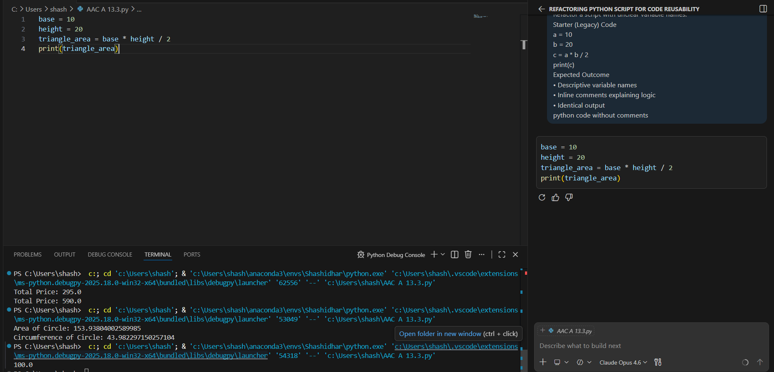  Note: Report should be submitted as a word document for all tasks in a single document with prompts, comments & code explanation, and output and if required, screenshots. |  |  |  |  |  | Week7 - Wednesday

